Project Design phase-I

Project solution architecture

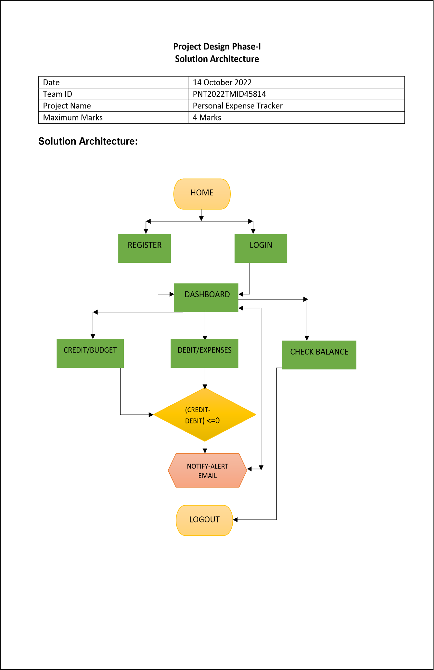Project Name: Personal expense tracker